**3-87)** Total phone numbers = 107, 1000 chances to call my number 1/107*1000=.0001

**3-89)** No; Not all possibilities have an equal probability. For example: P(X=1)=1/4*(3/4)9*10=.1877 P(X=2)=(1/4)2(3/4)8*10!/(2!(10-2)!)=.2816

**3-93)**

1. P(X<=2)=10C2*.12(1-.1)10-2=.9298
2. P(X>10)=0
3. P(X=4)=.9984-.9872=.0112
4. P(5<=X<=7)=1-.9984=.0016

**3-97)** f(x)=10Cx0.01x(1-.01)10-x

1. 0
2. 10

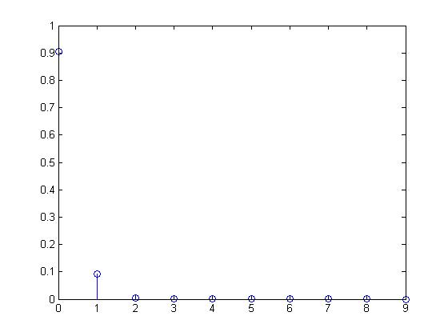

**3-109)**

1. Sum(125Cx*.1x*(1-.1)125-x,5,125)=.99614
2. Sum(125Cx*.1x*(1-.1)125-x,6,125)=.98857

**3-115)**

1. 1000C1000*.991000(1-.99)1000-1000=.00004317
2. 1000C990*.99990(1-.99)1000-990=.1257
3. Sum(1000Cx*.01x(1-.01)1000-x,3,1000)=.9973

**3-161)**

1. 1-Sum(e-1/16*16(1/16*16)x/x!,0,1)=.264241
2. 1-e-1/16*x=.95 where x is the number of cubic lightyears x=47.9317

**3-163)**

1. 1-Sum(e-.61(.61)x/x!,0,1)=.125205
2. e-.61*5(.61*5)0/0!=.0473589

**3-171)**

1. e-5*1/6(5*1/6)0/(0)!=.435
2. 1-Sum(e-5*1/3(5*1/3)x/(x)!,0,1)=.496332
3. e-m(m*1/6)0/(0)!=.1 mean=13.8155